# **Virginia Battlefields**

**Field Trip**

**Hosted by the Civil War Round Table of the Mid-Ohio Valley**

***September 13—15, 2024***

*Heroes of Chancellorsville*

1

## **Introduction and Overview**

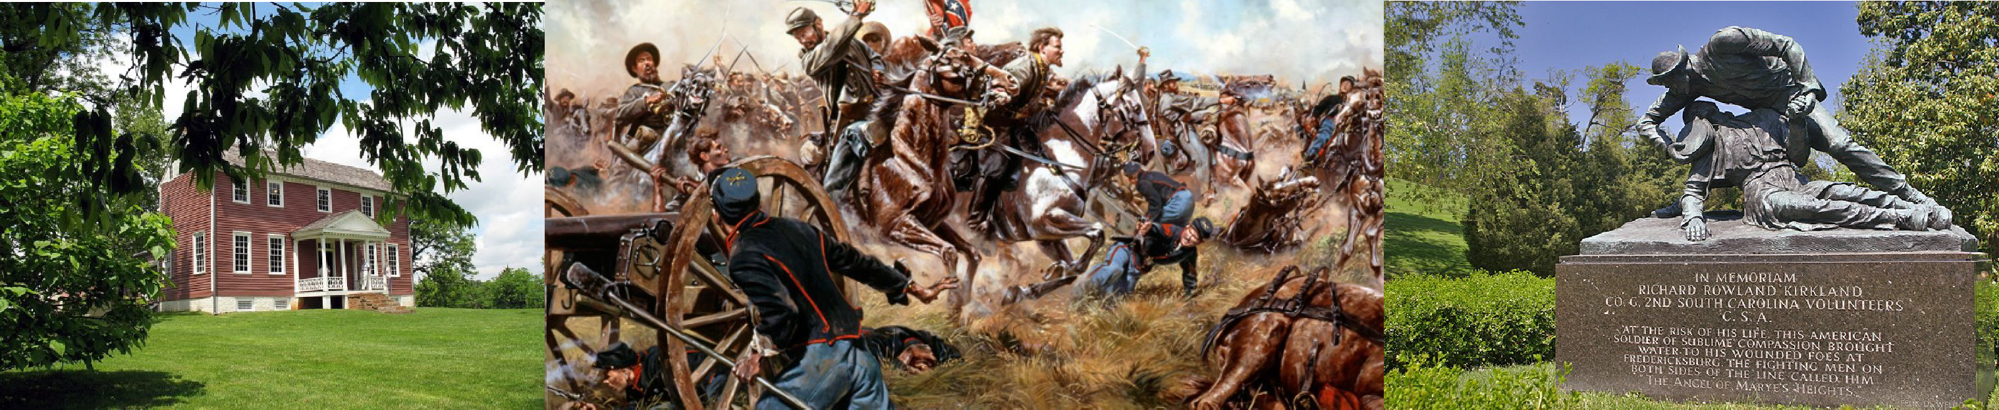

The Civil War Round Table of the Mid-Ohio Valley cordially invites you to join us for a gen- uinely one-of-a-kind Civil War field trip experience that will feature several of the bloodiest and most contested landscapes in the war. As always, our purpose is to recognize and honor the service, dedication and sacrifice of citizens and soldiers from Southeast Ohio and Northern West Virginia who served and sacrificed on these hallowed grounds:

* **Brandy Station Battlefield Park**
* **Chatham Manor, Fredericksburg VA**
* **Fredericksburg National Military Park**
  + **Fredericksburg National Cemetery**
    - **Chancellorsville Battlefield**

· **The Wilderness Battlefield and Ellwood Manor**

· **Guinea Station**

* + - **Massaponax Baptist Church**

· **Battle of Spotsylvania**

* + **Battle of Lewisburg (West Virginia)**

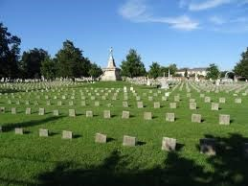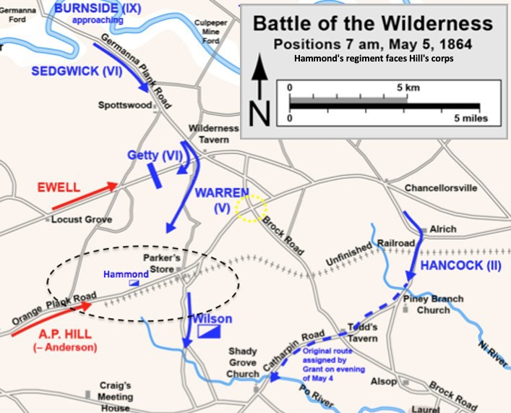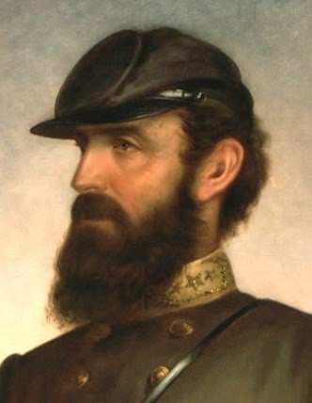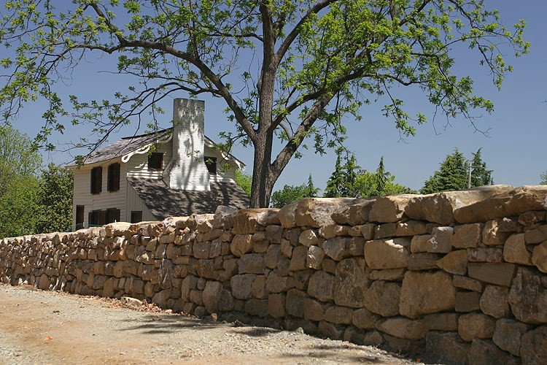

# **Guide and Speaker**

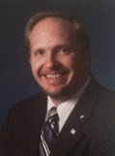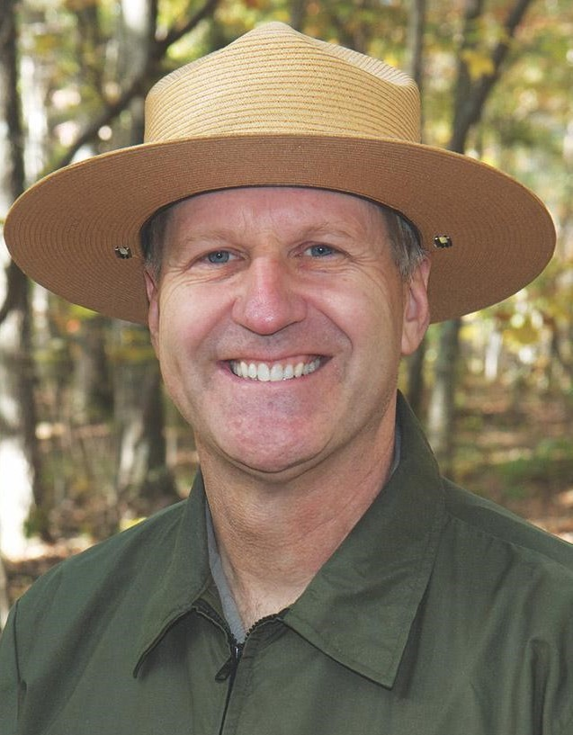

**Scott Britton Don Pfanz**

**Scott Britton** is Executive Director of The Castle Museum in Marietta, Ohio. He is a fre- quent speaker on a plethora of topics related to the Civil War and multicultural history in Southeastern Ohio. He conducts educational programs for students and adults, including frequent tours of Marietta’s historic cemeteries. Scott is a graduate of Penn State Universi- ty and is Past Commander of the General B. D. Fearing Camp #2 SUV and historian for the Marietta Chapter SAR. He co-founded the Civil War Round Table in 2012 and has served as guide on each annual field trip where he relates the stories of veterans from the region at the battlefield positions where they served our nation.

**Don Pfanz** is an author and staff historian at Fredericksburg and Spotsylvania National Military Park. He is a native of Gettysburg, PA, and graduated from the College of Wil- liam & Mary before joining the National Park Service. Prior to joining the Fredericks- burg and Spotsylvania NPS Staff he served at Petersburg National Battlefield and Fort Sumter National Monument. He is the author of five books including *No Turning Back: A Guide to the Overland Campaign; Richard S. Ewell: A Soldier’s Life; The Letters of Gen- eral Richard S. Ewell, Stonewall’s Successor;* and*, War So Terrible: A Popular History of the Battle of Fredericksburg.*

# **About Us**

The Civil War Round Table of the Mid-Ohio Valley was founded in 2012 and is a 501(c)3 non-profit corporation registered in OH and WV. Our mission is to commemorate, educate and encourage public interest in the American Civil War. We pursue our mission through these activities:

* Regular bi-monthly education programs are held in Marietta OH and Parkersburg WV
* Financial and volunteer support for Campus Martius Museum’s Annual Civil War Field Day
* Annual field trips—Proceeds fund our historical marker projects
* Historical marker projects

Please see [www.cwrtmov.org](http://www.cwrtmov.org/) for more information.

## **Historical Marker Projects**

**Funded by proceeds from annual Civil War Round Table field trips.**

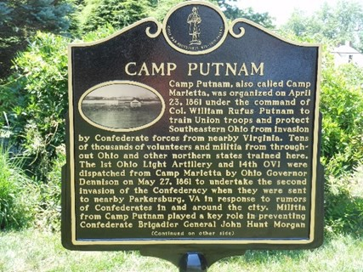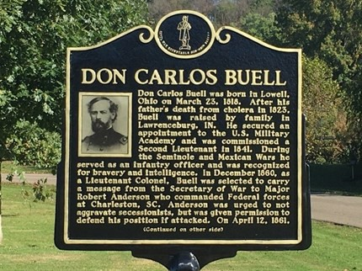

**Camp Putnam Brig. Gen. Don Carlos Buell Washington County Fair Grounds, Marietta, OH Buell’s Island, Lowell, Ohio Dedicated April 23, 2016, Dedicated October 7, 2017**

**Erected May 2016 Erected October 2017**

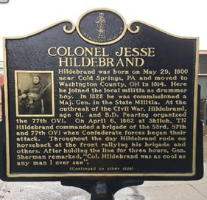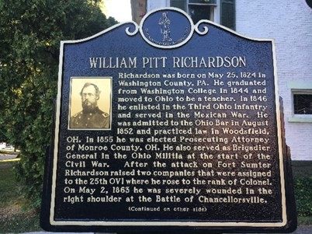

**Col. Jesse Hildebrand Brig. Gen. Wm. Pitt Richardson 161 Front Street, Marietta, OH 215 Washington Street, Marietta, OH Dedicated September 22, 2018 Dedicated December 1, 2018**

**Erected October 2018 Erected January 2019**

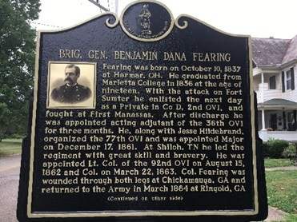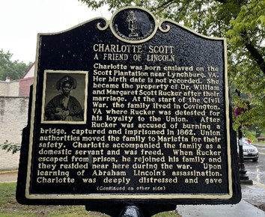

**Brig. Gen. Benjamin D. Fearing Charlotte Scott**

**131 Gilman Avenue, Marietta, OH 301 Putnam Street, Marietta, OH Dedicated May 18, 2024 Dedicated June 17, 2023**

**Erected June 2019 Erected July 2023**

# **General Information & Registration**

Field Trip Registration Includes:

* Charter bus transportation with departure from Lowes Home Improvement Center, 842 Pike Street, Marietta, at 6:00 a.m., and, WV Park & Ride at the intersection of US 50 and I-77, Parkersburg WV, at 6:20 a.m. on Friday, September 12, 2024.
* Admission and narrated tours of each of the attractions, battlefields, and sites in- dicated.
* Overnight accommodations at Country Inn & Suites by Radisson, 656 Warrenton Road, Fredericksburg, VA 22406 — See https://[www.radissonhotels.com/en-us/](http://www.radissonhotels.com/en-us/) brand/country-inn
* Dining venues in the nearby picturesque Fredericksburg Historic District are a short shuttle ride on the charter bus from our hotel and offer a diverse range of dining options and pricing. A local dining guide and map of the historic district will be provided following registration.
* Other than complimentary breakfasts provided by our hotel, no meals or gratuities are included.
* Our charter bus will return to the WVDOT Park and Ride in Parkersburg at ap- proximately 6:30 p.m. and Lowe’s Home Improvement Center in Marietta at ap- proximately 7:00 p.m. on Sunday, September 15, 2024.

Cost is $ 375.00/guest for double-occupancy or $ 495.00/guest for private accommoda- tions. Registration is limited and will be accepted on a first-come, first-served basis. Reg- istration may be completed online at [www.cwrtmov.org](http://www.cwrtmov.org/) or by forwarding the accompany- ing Registration Form with a deposit of $ 100.00/guest to: CWRT 2019 Field Trip, 515 4th Street, Marietta OH 45750. Checks may be made payable to “CWRT 2023 Field Trip”.

***No cash payments, please!*** Final payment is due Monday, August 5, 2024. All deposits and payments are fully-refundable. We reserve the right to cancel or amend any or all proposed activities in the event of unforeseen circumstances.

Additional information, including a detailed itinerary, official visitor’s information listing attractions and entertainment options in Frederick, recommended dining venues, sug- gested reading and viewing list, and updates will be forthcoming following registration.

We hope you will join us for our ***11th Annual* CWRT Field Trip** adventure following the remarkable deeds and dedicated service of local citizens and soldiers who sacrificed, and, in some cases perished, on these grounds in the service of our nation. We welcome your questions and thank you for your continuing support. **Please direct questions to Nancy Arthur, President, Civil War Round Table of the Mid-Ohio Valley, at nancyad-** [**vantage@yahoo.com**](mailto:vantage@yahoo.com) **or 740 525 7479.**

# **Registration Form**

**2024 CWRT Virginia Battlefields Field Trip September 13 – 15, 2024**

Guest Name(s):

Mailing Address:

Home Phone: Mobile Phone:

e-Mail:

Emergency Contact Name(s):

Home Phone: Mobile Phone:

Medical Condition(s)/Special Requests Including limited mobility:

Field Trip Remittance: Shared-Double Occupancy - $ 375.00/guest Single Occupancy - $ 495.00/guest Hotel services include complimentary breakfast, wireless internet, fitness center and swimming pool.

|  |  |  |  |  |  |  |
| --- | --- | --- | --- | --- | --- | --- |
| Plan to share a room?  Help, I need a roommate! | l l Yes  I I Yes | I I No  I I No | Roommate’s Name | | | |
| Remittance Summary: | | Number of Guests | | Rate/Guest |  | Remittance |
| Field Trip: | | x | | $ | = | $ _ _ _ _ _ _ _ _ _ _ _ _ |
| Less: Deposit | | x | | $ 100.00/Guest | = | $ _ _ _ _ _ _ _ _ _ _ _ _ |

Balance Due: Monday, August 26th, 2024 = $

I/we have elected to participate in a field trip organized by the Civil War Round Table of the Mid-Ohio Valley (“CWRT”) to visit historic and cultural sites on Friday, September 13th through Sunday, September 15th, 2024 (“Tour”). CWRT has contracted bus transportation, accommodations, site visits, attractions and meals indicated. I understand that while CWRT has used its best efforts in selecting each service provider, CWRT is not responsible for the services or for any ac- tion or inaction of any employee, agent, or other person providing such services. I also understand that the Tour will require walking and climbing steps, and I am able to do so without undue risk to myself and others. In consideration of CWRT agreeing to allow me to participate in the Tour, on my own behalf and for my heirs and representatives, I do here- by release and discharge CWRT, its officers, agents, volunteers and representatives, from any and all liability for any in- juries or damages which I may suffer by reason of my participation in the Tour and I wave any right to sue and any aims for such injuries or damage, except for any injuries or damage directly resulting from the active negligence of a CWRT officer, agent or representative.

Guest Signature: Date:

Guest Signature: Date:

Registration is limited and will be accepted on a first-come, first-served basis. Please forward Registration with deposit in the amount of $ 100.00/guest to: CWRT 2024 Field Trip, 515 4th Street, Marietta OH 45750. Please make checks payable to “CWRT 2024 Field Trip”. **No cash payments please!** All payments are fully refundable upon request. Addi- tional information, including a detailed itinerary, official visitors’ information guides listing attractions and entertain- ment options for various Virginia locations, suggested reading and viewing materials, recommended dining venues, and updates will be forwarded following receipt of registration. Lastly, please retain a copy of your registration form for your records.

*As always, Thank You for your Support!!!*

|  |  |
| --- | --- |
|  | **HARDSCRABBLE**  Civil War Round Table of the Mid-Ohio Valley Newsletter  June, 2024 – Vol 30 |

***Notes from Nancy Arthur***

What a busy month of May! If you couldn’t attend the General Fearing marker dedication on May 18th on Gilman St. in front of the Fearing Museum, see the information as part of this newsletter.

Many thanks to the Marietta High School Choir for opening the ceremony with our National Anthem, Boy Scout Troop #203 for leading us in the Pledge of Allegiance, SUVCW Color Guard, remarks by Director of The Castle Scott Britton, then the remarkable performance by the high school choir of Tell My Father. The museum served us great strawberry shortcake afterwards and filled the backyard of the museum with activity.

And on July 13th from 10 – 3, our Round Table will be hosting the first ever History in the Park, immediately following the Dedication to the Northwest Territory. Find all of this in Muskingum Park, Front St. Marietta. Various museums and other history related organizations will be setting up in the park, plus the First Congregational Church, across from the park, will be giving tours of this beautiful church. And so much more!

Coming on July 18th @ 7:00 at the St. Luke’s Episcopal Parish Hall, located at 320 2nd St. Marietta will be Scott Britton presenting “First Stop on the New Journey to Freedom”, About the Underground Railroad in Washington County.

And of course, look for the registration to the September Field Trip to the Battlefields of Virginia, on the website. Civil War Round Table of the Mid-Ohio Valley.

24

**Ilene Evans Hermina Glass-Hill**

Community Celebration co**-**hosted by the Marietta College OfÕce of Diversity and Inclusion and Civil War Round Table of the Mid**-**Ohio Valley

Free and Open to the Public

Picnic, Music, Children’s Games, Giveaways Ilene Evans, Artistic Director, Voices from the Earth,

will portray Harriett Tubman

Hermina Glass**-**Hill, Executive Director, Susie King Taylor Women’s Institute and Ecology Center, will present on the remarkable lifetime achievements of Ms. Taylor

5:30**—**8:00 p.m., Friday, June 14, 2024 Hermann Fine Arts Center, 500 Butler Street,

Marietta, OH

[www.cwrtmov.org](http://www.cwrtmov.org/)

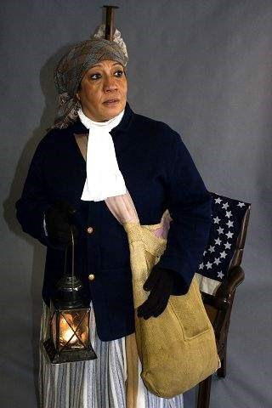

Community Celebration co**-**hosted by the Marietta College OfÕce of Diversity and Inclusion and Civil War Round Table of the Mid**-**Ohio Valley

Free and Open to the Public

Picnic, Music, Children’s Games, Giveaways Ilene Evans, Artistic Director, Voices from the Earth,

will portray Harriett Tubman

Hermina Glass**-**Hill, Executive Director, Susie King Taylor Women’s Institute and Ecology Center, will present on the remarkable lifetime achievements of Ms. Taylor

5:30**—**8:00 p.m., Friday, June 14, 2024 Hermann Fine Arts Center, 500 Butler Street,

Marietta, OH

[www.cwrtmov.org](http://www.cwrtmov.org/)

